**Project-3: Eleven Labs :-**

**Prerequisites:**

1. **Eleven Labs Account:**
   * You need an **Eleven Labs** account to use their API for making outbound calls.
2. **Twilio Account:**
   * A Twilio account is required to purchase a phone number and make calls.
3. **Cursor IDE & Virtual Environment:**
   * Ensure you have **Cursor IDE** and a **virtual environment** set up to run Python commands for installation.
   * Python 3.10+ is installed on your system.  
     i. [Python installation on Windows](https://www.youtube.com/watch?v=0DQsjE8vMpc)  
     ii. [Python installation on Mac](https://www.youtube.com/watch?v=0DQsjE8vMpc)

Process:

**Step 1: Set Up Eleven Labs API Key**

1. **Open the Eleven Labs Page:**
   * Go to the Eleven Labs website and sign up or log in to your account.
   * [Eleven Labs](https://elevenlabs.io/app/conversational-ai)
2. **Generate API Key:**
   * In the **left-bottom corner**, click on your **profile** and select **API keys**. 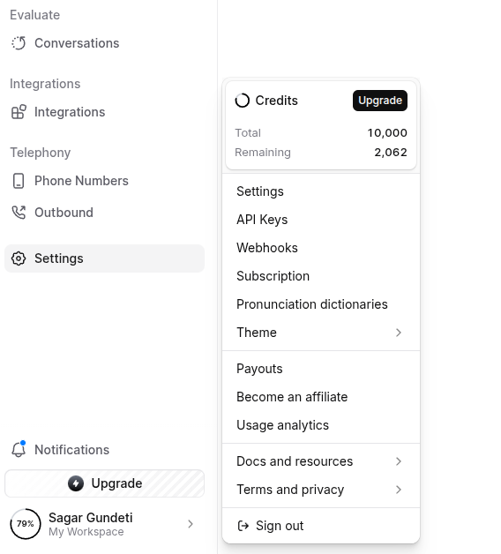
   * Click on **Create API Key**.
   * **Turn off the restrict key option.**  
     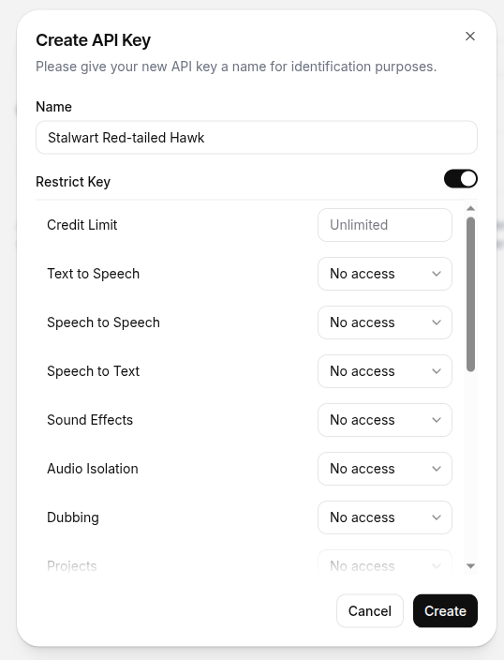
   * Create the API key and **copy it**. You will need this API key for the next steps.  
     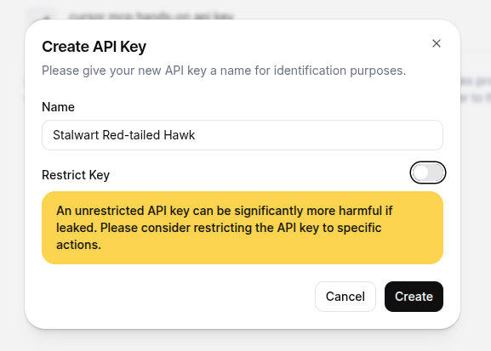
   * Store the API key somewhere for use in the following steps.

**Step 2: Set Up Twilio**

1. **Open the Eleven Labs Page:**
   * Go to the Twilio website and create an account. Authenticate it with the code sent to your email.
   * [Twilio](https://console.twilio.com/)
2. **Add Your Phone Number:**
   * Add your phone number and verify it using the **OTP**. 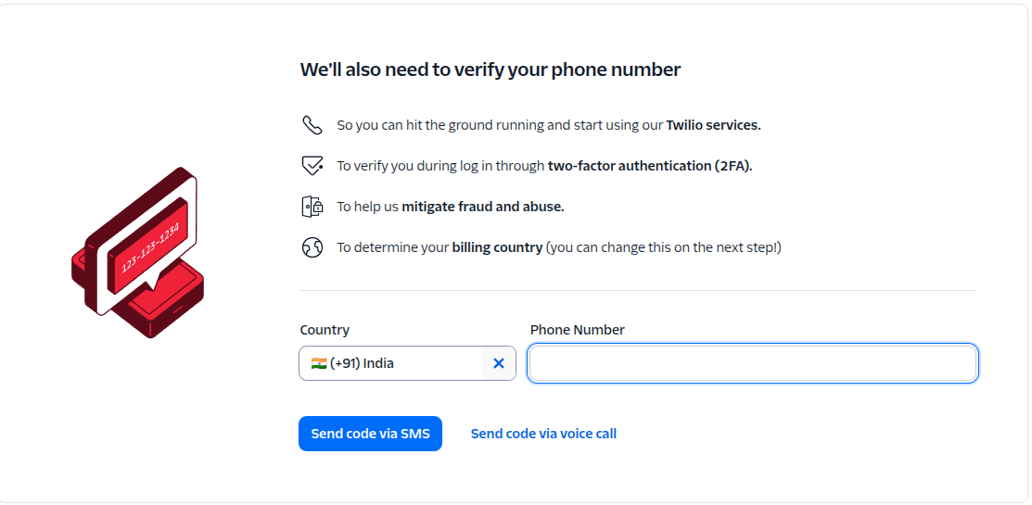
   * Click on **Continue** to complete the onboarding process.
3. **Buy a Twilio Number:(It will be used with free trial credits.)**
   * If you don’t find “Phone Numbers” in the “Develop” section, click on “Explore Products.” In the “Super Network” section, you will find “Phone Numbers.” Please **pin** it for further use. 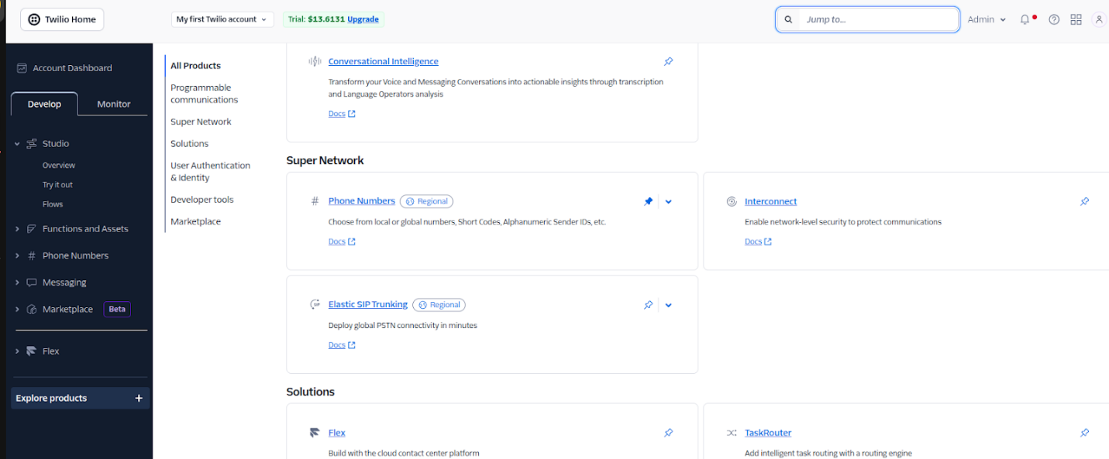
   * On the **left side "Develop" section**, click on **Phone Numbers -> Manage**.
   * Click on **Buy a Number**. 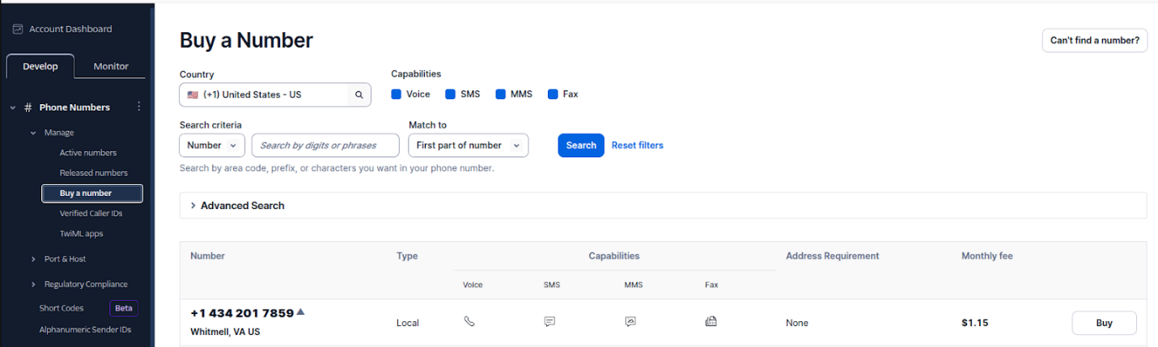
   * Select a phone number and click on **Buy**.
   * A pop-up will appear, and tick the Terms & Conditions box.

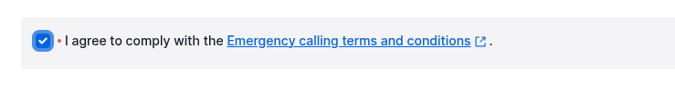

1. **Configure the Twilio Number:**
   * Click on **Review Phone Number** to confirm the purchase.
   * After confirmation, click on the **Configuration Button**.
   * Select the number you just purchased. In the **Voice Configuration**, find the **"A call comes in"** row and update the URL with: https://api.us.elevenlabs.io/twilio/inbound_call 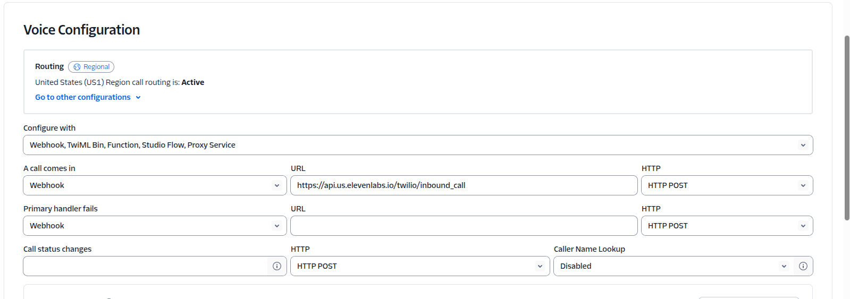
   * Click on Save Configuration.

**Step 3: Integrate Twilio with Eleven Labs**

1. **Import Twilio Number into Eleven Labs:**

Go to the **Eleven Labs tab** and select **Conversational AI(left side, top corner)**.

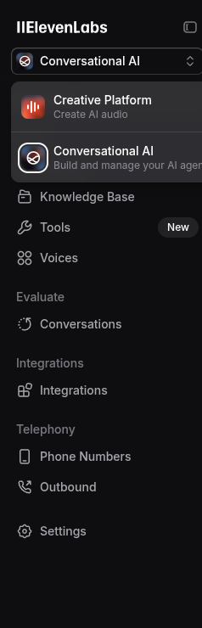

* Click on **Phone Numbers** (left panel).
* Click on **Import Number** and select **Twilio** from the right panel.
* Give it a **label name**.
* **Copy the Twilio phone number** and paste it in the provided field.

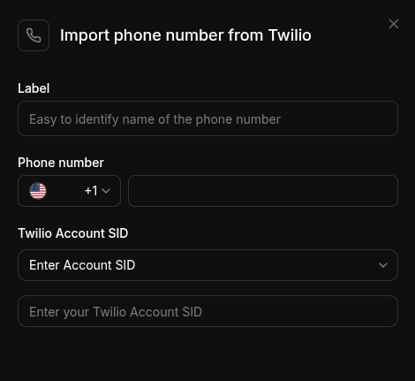

* + Click on **Account Dashboard** to return to the homepage. 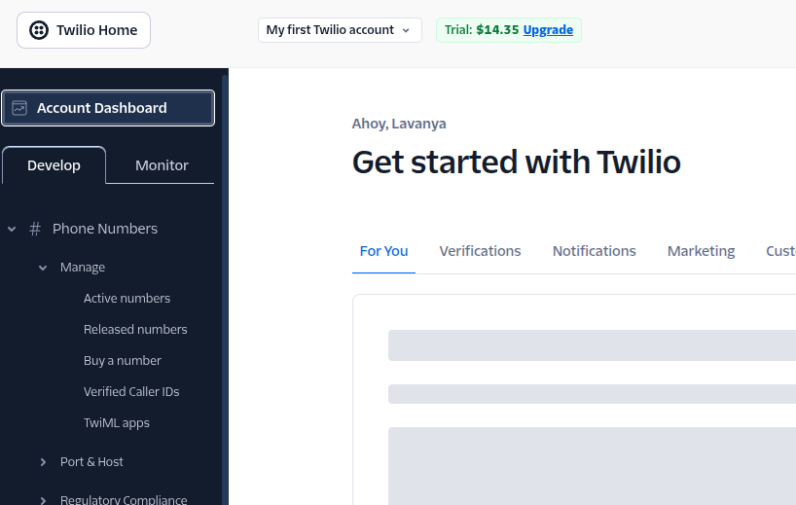
  + **Copy the Account SID** and **Auth Token** from Twilio.(In the **Account Info** Section)

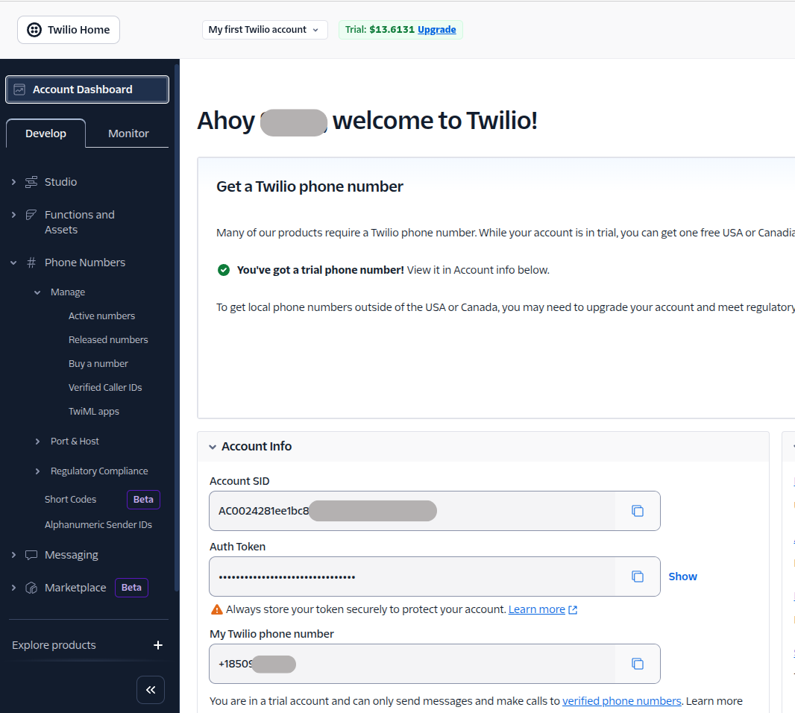

* + Paste them into **Eleven Labs** and click **Enter**.
  + Your **Twilio phone number** is now integrated with **Eleven Labs**.

**Step 4: Install and Set Up MCP for Eleven Labs**

1. **Open the Terminal in the Cursor IDE:**  
   Click on **Terminal** (right side top section it will be available)
2. **Install MCP Dependencies:**

Run the following commands:

**pip install elevenlabs-mcp**

**python -m elevenlabs_mcp --api-key={{paste your elevenlabs api key}}**

Example sample python -m elevenlabs*mcp --api-key=sk*1235 --print

1. **Check Response:**  
   After running the command, you will get a response like this:

**"mcpServers": {**

**"ElevenLabs": {**

**"command": "/home/da-002/Codes/practice_env/bin/python",**

**"args": ["/home/da-002/Codes/practice_env/lib/python3.12/site-packages/elevenlabs_mcp/server.py"],**

**"env": {**

**"ELEVENLABS_API_KEY": "sk_1235"**

**}**

**}**

**}**

**}**

1. **Set Up MCP Server in Cursor:**
   * Copy and paste the above JSON into the **Cursor MCP JSON file**. This will configure the server.

**Step 5: Create a Tech Update Agent**

1. Prompt 1:

Create an agent that makes an outbound call to update someone about recent tech news

* Use a confident, friendly tone — like a helpful colleague
* Deliver updates about the latest in AI, programming, and cybersecurity
* Keep the explanation short, clear, and jargon-free
* Use my voice (female) for the call
* The agent should sound like a tech-savvy friend, not a sales rep
* First message: "Hey, I’ve got some quick tech updates for you — should I go ahead?"

You don’t have to make a call. Create an agent in the ElevenLabs simply

The agent will be created in Eleven Labs.

1. Prompt 2:

Now make an outbound call to my number, ask for my number

It will ask for a number to call

**Note:** 1. A call will be initiated to your **Twilio-logged number**. 2. It will ask you to click on any number, as we are using the free trial of Twilio. Click on the number, and an **agent** will be connected. 3. A call will be connected to **the Eleven Labs agent**. 4. The **agent will provide you with the tech update**.